ARE YOU A FILM BUFF?
DO YOU ENJOY SHARING YOUR LOVE FOR MOVIES WITH OTHERS?
DO YOU DREAM TO GO TO THE VENICE FILM FESTIVAL?

28 TIMES CINEMA WILL TURN YOUR DREAM INTO REALITY!

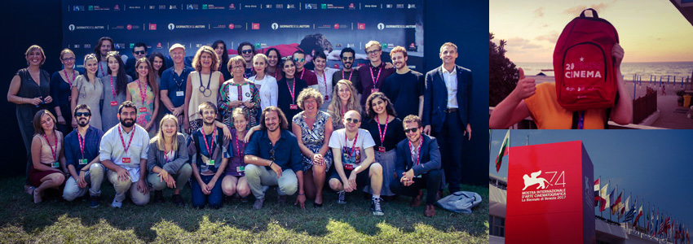

28 TIMES CINEMA* invites 28 young European filmgoers (one participant per member state of the European Union) to attend the 2018 Venice Film Festival as Jury Members of the Giornate degli Autori selection.

Who can participate?
- Film lovers aged between 18 and 25,
- Excellent English skills (reading, written and spoken) are required,
- Good ability to write articles and blogs.
How to participate?
- Do and send a video-selfie in which you explain what cinema means for you. Start the video saying “Cinema for me is…” Make it fun and original!

Technical requirements:
- Shoot it in English,
- In high resolution (Full HD: 1920x1080 px) and with an excellent audio recording,
- Duration: 30 seconds,
- The video should contain the following information: Name and country of origin.

Take a look to the Europa Cinemas’ Vimeo channel to check out previous year’s examples.

- Send the application form filled in English to the cinema (…) before the (….)
What happens if you’re the lucky one?
You win a flight ticket to Venice and get free accommodation in the Lido where the festival takes place. You’ll be offered a free festival accreditation (giving also priority access to the Giornate degli Autori screenings).

Important: You should commit yourself to:
- Be present in Venice before the start of the festival from Tuesday 28th of August to Sunday 9th September 2018,
- Be a Jury Member for the films competing for the Giornate degli Autori selection,
- Watch all the films presented at the Giornate degli Autori and at the LUX Prize 2018 Competition,
- Take part in round tables, discussions and debates with filmmakers and other guests,
- Contribute to a blog, which will be specifically developed for this event and to the media partners websites,
- Write a daily postcard for Europa Cinemas’ social networks,
- Be an active ambassador for the Lux Film Prize during the events organised after Venice in your country.
Don’t miss this unique opportunity! Let your dream become true!

*Co-organised by the European Parliament, the LUX Prize, the Giornate degli Autori and Europa Cinemas, 28 Times Cinema aims to promote shared values and cultural diversity through cinema among young people.

For further information about this initiative please visit: http://www.luxprize.eu/28-times-cinema http://www.venice-days.com/-http://www.europa-cinemas.org/Les-actions/28-Times-Cinema-http://webreporters.cineuropa.org/-https://storify.com/europacinemas/28-times-cinema-2015-https://europa-cinemas-blog.org/about/28-times-cinema/

